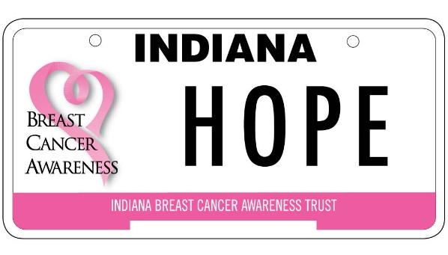

Nancy Jaynes Memorial Breast Cancer Survivor

College Scholarship Award

Application Announcement

The Nancy Jaynes Memorial Scholarship Award is named in honor of the founder of the Indiana Breast Cancer Awareness Trust (IBCAT), Nancy Jaynes. Nancy lost her battle with breast cancer in March 2008. Nancy was a Plymouth (Indiana) High School Family and Consumer Sciences teacher. She envisioned the breast cancer license plate to be a traveling billboard and reminder about the importance of early detection and prevention of breast cancer. The mission of the Indiana Breast Cancer Awareness Trust is to increase awareness and improve access to breast cancer screening, diagnosis and support services throughout Indiana. To date, IBCAT has funded over $7.5 million in grants and services supporting our mission in addition to $179,750 in scholarships.

IBCAT is currently accepting applications for the Nancy Jaynes Memorial Breast Cancer Survivor Scholarship. The scholarship of up to $2,500 for post-secondary schooling is awarded to a currently enrolled, full-time student who is a breast cancer survivor. A breast cancer survivor is anyone who has been diagnosed with breast cancer, from the day of their diagnosis through the rest of their life. Application guidelines and instructions are included in this announcement.

Fully Completed Application & Attachments must be received by

Wednesday, August 12, 2026.
Incomplete applications will not be reviewed.
Signed Emailed & Mailed applications will be considered.
Contact information for submission and inquiries:

Indiana Breast Cancer Awareness Trust
P.O. Box 8212
Evansville, IN 47716

Phone: 866.724.2228 (toll free)
Email: info@breastcancerplate.org
DO NOT INCLUDE PAGES 1 & 2 WITH APPLICATION. THESE PAGES ARE FOR YOUR INFORMATIONAL PURPOSES ONLY.

Guidelines and Instructions

Purpose: The purpose of the Indiana Breast Cancer Awareness Trust, Nancy Jaynes Memorial Breast Cancer Survivor Scholarship Award is to provide financial assistance for a breast cancer survivor to attend a post-secondary educational program (technical school or college) through scholarship funds.

Eligibility Requirements: In order to be eligible for consideration, scholarship applicants must:
- Have been diagnosed with breast cancer. (Physician verification form must be completed.)
- Be enrolled as a full-time undergraduate student in an accredited post-secondary institution in Indiana.
- Have a cumulative post-secondary GPA of 2.8 or better on a 4.0 scale. If entering as first-year post-secondary student, the student’s high school GPA must also be 2.8 or better on a 4.0 scale.
- Be a resident of Indiana and a U.S. citizen, or documented permanent resident of the U.S. Race, color, creed or sex will not be factors in choosing the Award winner(s).
- Recipients will be asked to provide proof of enrollment for the fall semester.

Application Submission Instructions: In order to be eligible for consideration, scholarship applications must:
- Be typed (preferred) or printed in blue or black ink on only one side of the page. Essays must be typewritten.
- Be clearly legible and submitted in English. IBCAT is not responsible for mistakes made due to illegible applications.
- Include current and accurate contact information. IBCAT will contact you at the phone number, email address, or physical address you provide.
- Provide all signatures as indicated on the application.

Application Timeline:
August 12, 2026: | Completed application and official transcript due to IBCAT.
August 21, 2026: | Scholarship award winner(s) will be notified by phone, mail or e-mail. The names and photographs of scholarship winners may be used by IBCAT for public relations purposes.

Application Checklist: Please submit application items in the order listed. Recommendation letter and Physician Verification Form may be sent separately by the submitting party and must also be received by August 12, 2026.

- Fully Completed and Signed Application
- Official College Transcript or High School Transcript if just entering college
- One Letter of Recommendation from non-family member
- Essay on Topic Provided
- Physician Verification Form

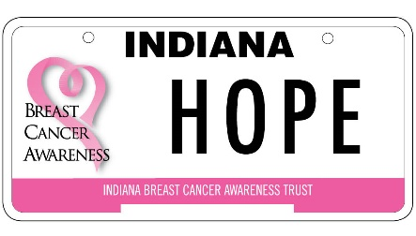 | Nancy Jaynes Memorial Scholarship Award  Application Form

Applicant's Full Name:
 | First | Middle | Last
Street Address:
City, Zip Code
Mailing Address (if different):
City, Zip Code
Birth Date:
Phone Number (Daytime):
Email:
How did you hear about this scholarship program?

Year Diagnosed: |  | Current Treatment Plan:

Current Educational Data:

Post-Secondary School Attending:
Street Address:
City, State , Zip:
Main Phone Number:

Major or area of study
What is your career goal?
Do you plan to live: On campus _______ |  | At home _______
Off campus_______ |  | Unknown _______

*Campus Activities – includes clubs, sports, student associations, etc.

Name of Organization | Activities/Leadership Roles | Years Involved

*Community Service (post high school) – non-paid service rendered in the community

Name of Organization | Activities/Leadership Roles | Years Involved

Company | Your specific role/job title: | From-Thru: | Hrs/week:
*Employment/Internships/Summer Activities (post high school)

*Please add additional lines or continue on another page if necessary.

ESSAY

Applicants are required to write an essay on: “Describe a unique situation or experience which occurred as a direct result of your breast cancer journey. How did this situation or experience provide personal growth.”

The Award Committee is concerned about the quality of your writing, but more importantly, about the quality of your thinking.

Your essay should be typed, double-spaced. It should be no more that 12-point font size and be no longer than 500 words. Include your name at the top of each page.

Scholarship Agreement

I certify that the information on this application and the supporting materials are complete, factually correct, and honestly presented. I further certify that, to the best of my knowledge, I meet all eligibility criteria noted above and understand the scholarship is contingent upon the following items:

- I must attend an accredited post-secondary institution in Indiana.
- I agree to the release of college transcripts and requested information to IBCAT. Furthermore, my name and photograph may be used by IBCAT for public relations purposes.
- I hereby consent to the Indiana Breast Cancer Awareness Trust (IBCAT) contacting my supervising physician to verify that I have had a breast cancer diagnosis. This consent expires thirty (30) days after the date below.

_______________________________________________
Applicant’s Signature

_______________________________________________
Applicant’s Name (Printed)

____________________________
Date

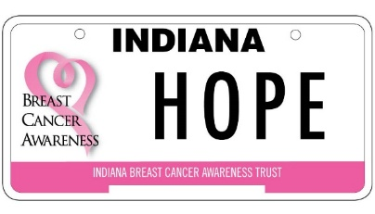

The Indiana Breast Cancer Awareness Trust (IBCAT) exists to increase awareness and improve access to breast cancer screening, diagnosis and support services throughout Indiana. Through this program we provide college scholarships to individuals who have received a breast cancer diagnosis regardless of treatment status. To qualify, applicants must have been diagnosed with breast cancer and be an Indiana resident who will be attending an Indiana accredited post-secondary institution on a full-time basis.

PHYSICIAN VERIFICATION FORM
This section must be completed by listed patients’ oncologist, general physician or nurse navigator. By completing this form, you verify that all information is accurate and true.

Patient Information:

Full Name: (First, MI, Last) _____________________________________________________________________________

Address: ______________________________________________________ City: _________________________________

Official Diagnosis Breast Cancer Diagnosis: ______________________________________________

Diagnosis Date:

Physician Information

Treating Physician: ________________________________________________________

Healthcare System/Group: _____________________________________________________

Phone:

Individual Completing Form:

Name:____________________________________________________

Title:_____________________________________________________

Phone:__________________________________ Email:_______________________________________________

Signature: _______________________________________________________

Submission Information/Questions:

This form may be returned to the patient for submittal or submitted directly by email to Indiana Breast Cancer Awareness Trust at info@breastcancerplate.org. August 12, 2026 is the application deadline. Questions? Call us at 866.724.2228 or email at info@breastcancerplate.org

