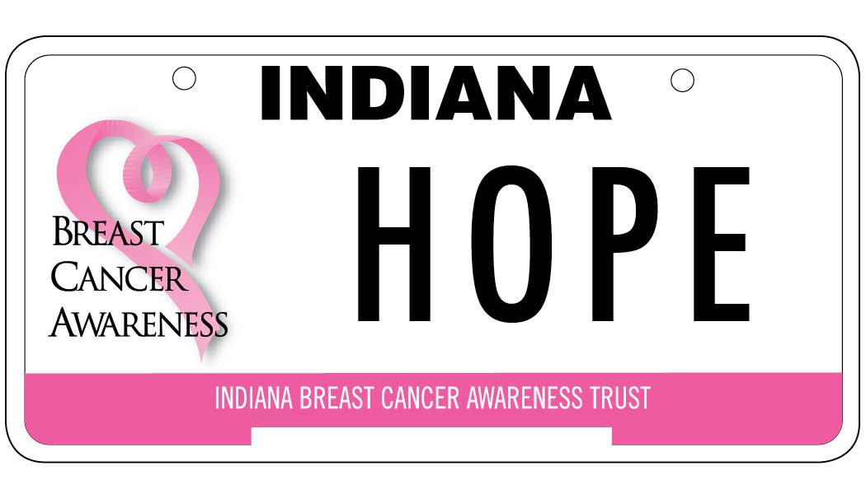

INDIANA BREAST CANCER AWARENESS TRUST, INC.
Now Open: Breast Cancer Screening & Diagnostic Grant

About the Grant
The Indiana Breast Cancer Awareness Trust, Inc. (IBCAT) works to increase awareness and expand access to breast cancer screening, diagnostic, and support services across Indiana.

Funding for this work comes from sales of the Indiana Breast Cancer Awareness specialty license plate. Since the plate launched in 2002, over $7.5 million has been awarded in grants and scholarships to help Hoosiers in need. Each plate sold generates a $25 donation, directly supporting breast health programs across the state. IBCAT is a 501(c)(3) nonprofit organization incorporated in the State of Indiana.

Eligibility & Guidelines
- Projects must provide screening or diagnostic services to uninsured or underinsured women or men in financial need
- Services must occur within the State of Indiana, for Indiana residents only
- Applicants must be a U.S. nonprofit (federally tax-exempt) organization
- Organizations may submit one application per grant type per facility
- Funding limits apply. Reimbursement is based on current Medicare rates — see the application for details
- Funded projects require a signed grant contract and submission of:
  - Quarterly financial reports
  - 6-month progress report
  - Final year-end report

Important Dates
- Grant Application Due: Delivered by mail no later than Thursday, October 9, 2025.
- Electronic Copy Due: No later than 6:00 pm CST, Wednesday, October 8, 2025. Email to info@breastcancerplate.org
- Award Announcements: By December 15, 2025
- Grant Period: January 1-December 31, 2026

Apply Today
We invite you to consider becoming a part of our mission: Applications are now being accepted.
- Download the application at BreastCancerPlate.org/programsgrants/grant-programs
- Get guidance and tips in our Grant Writing Manual

Questions? Contact our office: 866.724.2228 or info@breastcancerplate.org

