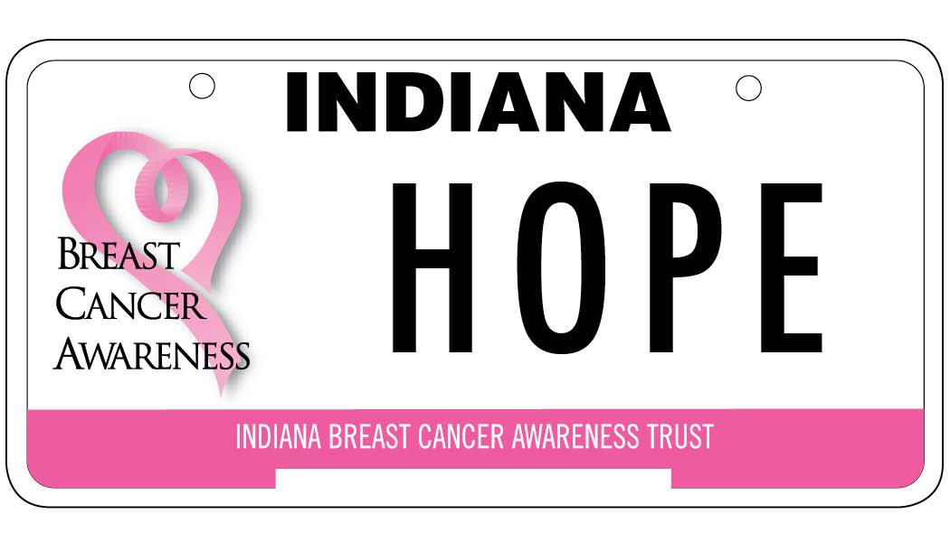
NOTE: THIS SHEET IS INFORMATIONAL ONLY.
DO NOT INCLUDE AS PART OF GRANT APPLICATION.

Step 1: Complete the Application

Each response should appear under the question, not on a separate sheet, in the order provided. Incomplete, out of order and/or late applications submittals may be rejected.
Additional information: 2026 Breast Health Services Program Guidelines

Step 2: Include Required Attachments
- Sample of Patient Application/In-Take Form – All grant programs must have a process for qualifying IBCAT patients (age, income, etc.) into their screening/diagnostic program.
- Letter(s) of Agreement (if your facility is not the mammography/radiology provider) clearly stating the other party’s acceptance of IBCAT reimbursement rates must be provided.
- IRS Determination Letter showing proof of Non-Profit Status. (State Sales Tax Exemption Certificate is not applicable.)

Step 3: Submit Hard Copies of Application by Mail

Ten (10) copies of the application and all attachments must be RECEIVED by Thursday, October 9, 2025. Each copy of the application/attachments should be individually stapled packets. No paperclips or binders. Double-sided printing is acceptable. These should be the only submitted documents. Do not include a cover letter or letters of collaboration, or this Informational page.

No Certified Mail. No Signature Required for Release. We suggest Priority Mail with tracking or Overnight w/o signature. Mail USPS standard or Priority Mail to:
Indiana Breast Cancer Awareness Trust
P.O. Box 8212
Evansville, IN 47716

Step 4: Submit Electronic Copy of Application by Email
One PDF copy of your application should be emailed to info@breastcancerplate.org by 6:00 pm on Wednesday, October 8, 2025.

Questions? Contact our office: 866.724.2228 or info@breastcancerplate.org

INDIANA BREAST CANCER AWARENESS TRUST, INC.

REQUEST FOR GRANT FUNDING: COVER PAGE

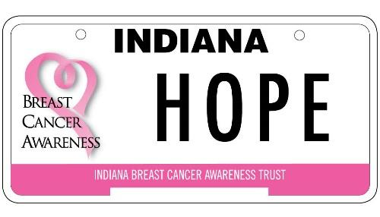

Application for Breast Cancer Screening & Diagnostic Programs
(Each Section of the Application is worth five (5) points.)

Organization Name
Project Director & Title
Street Address
City, State, Zip Code
Email
Phone Number
Federal Tax ID #
Grant Contact & Address (if different from Project Director)
Phone Number
Email
Patients in Need of Assistance should contact: |  | Name:  Phone:
Title of Project
This Project is: (check one) |  |  | New Program for 2026 |  | Existing/Continuation
Total Amount Requested
(Must be in accordance with Guidelines of Section 5 of application).
MUST match Budget Form – No Rounding
Grant Period |  | 01/01/2026 to 12/31/2026
Name & Title of Approving  Organization Personnel (Typed) |  |  |  |  |  | Date
Signature of Approving Organization Personnel

By signing this document permission is hereby granted to the Indiana Breast Cancer Awareness Trust to publish this award should your application be selected for funding.

PROJECT/ORGANIZATION INFORMATION

Title of Project:
Organization:

Will your grant program EXCLUDE any of the following? (check all that apply):

 | Caucasian |  | Urban |  | Age 40-49
 | African American |  | Rural |  | Age 50-64
 | Hispanic |  | Under 40 (family history only) |  | 65 & Over
 | Other: (specify)

Poverty level to be served:

 | 200% & below |  | 250% & below |  | 300% & below (IBCAT Recommended)
 | Other: (specify/details)
*Patient application/intake form should show how patients are qualified for your program. See checklist at end of application.

Counties to be served through this IBCAT Grant Program:
Begin with PRIMARY county(ies) first. Add additional lines if needed.

County | Population* | # of Mammograms performed/  facilitated**  in this county by our organization this year |  | County | Population* | # of Mammograms performed/  facilitated**  in this county by our organization this year
*Use current Census statistics - https://www.census.gov/quickfacts/fact
**”Facilitated” applies to organizations who refer mammography services to partner radiology sites.

Total Counties to be served through this Grant: |  | Total Population served through this Grant:

If this is a new program, does your organization have experience developing and implementing programs for the specified target population?

If this program is an existing/continuation program funded by IBCAT:

 | # of Years |  | # of women served in CURRENT IBCAT grant cycle.

Are you an Indiana Breast & Cervical Cancer (IN-BCCP) Provider/Enrollment Site?

 | Yes, we an Enrollment Site |  | No, we are not an Enrollment Site

This program is currently funded by:
Include donor and grant funding. Add additional lines if needed.
Funding earmarked by your organization:  Current Funding: $  Funding Ends: | *Other:  Current Amt. Funded $  Funding Ends:
Indiana Breast Cancer Awareness Trust (IBCAT)  Current Amt. Funded $  Funding Ends: | *Other:  Current Amt. Funded $  Funding Ends:

APPLICATION NARRATIVE

SECTION #1 – Project Overview
(Not to exceed three (3) pages for this entire section)

Project Description

Statement of Need

On the chart below, provide the requested information on the counties the grant intends to serve. (Add additional rows as needed. Additional space will not be counted toward your three (3) page maximum for this section.)

County | Poverty Rate | Uninsured | Unemployment Rate (most current year)
The source for the Poverty rate is: www.stats.Indiana.edu
The source for the Uninsured is: www.census.gov
The source for Unemployment Rate is: https://www.stats.indiana.edu/maptools/laus.asp

Provide a narrative around the current state of breast cancer in your community, including local mammography rates, barriers to screening services, breast cancer diagnosis statistics, etc. (Do not give national statistics.)

List and describe the primary goals of the project and detailed plans to achieve these goals.

How is this project unique compared to other breast cancer screening programs in your service area?

SECTION #2 – Project Sustainability
(Not to exceed two (2) pages for this entire section)

What resources does your organization (and your service provider, if applicable) have for this project – facilities, equipment, partnerships?

How will you recruit patients/participants for your project? (Note: All applicants are required to submit a patient application/in-take form for qualifying patients for the screening program. See Required Attachments on Informational Page.)

What potential challenges do you foresee and how will you overcome them?

SECTION #3 – Timeline
(Not to exceed one (1) page for this entire section)

Timeline for Implementing Your Program.

SECTION #4 – Defining Success
(Not to exceed one (1) page for this entire section)

How Will You Define Program Success?

Section #5 – Funding Levels & Project Budget

Grant Budget & Funding Levels – Complete the Budget Form on the following page. Funding Levels are to be in agreement with counties listed in the Project/Organization Information section (page 2) of this application.

# of Counties | Population &  Maximum Grant | Population &  Maximum Grant | Population &  Maximum Grant
1 – 6 | <100,000 = $5,000 max. | 100,001-299,999 = $10,000 max | >300,000 = $15,000 max
7 – 14 | <400,000 = $20,000 max | 400,001-599,999 = $25,000 max | >600,000 = $30,000 max
15+ | $40,000 max

Narrative explanation justifying the proposed budget.
(Not to exceed one (1) page)
Existing IBCAT grantees should address any sizeable increase over past grant amount(s).

Detailed Budget for Entire Budget Period
From January 1, 2026 through December 31, 2026

Patient Care Costs: (Based on Medicare Reimbursement Rates)

Code | Service Description | # |  | Rate |  | Sub-Total
77067 | Screening Mammogram (Digital) |  | @ | $116.03 | = | $
77063 | Tomosynthesis (Screening) |  | @ | $47.91 | = | $
77065 | Diagnostic, Unilateral (Digital) |  | @ | $113.63 | = | $
77066 | Diagnostic, Bilateral (Digital) |  | @ | $143.34 | = | $
G0279 | Tomosynthesis |  | @ | $40.46 | = | $
76641 | Ultrasound breast complete |  | @ | $92.39 | = | $
76642 | Ultrasound breast limited |  | @ | $76.76 | = | $
19000 | Drainage of breast lesion |  | @ | $87.21 | = | $
19001 | Drain breast lesion add-on (used w/19000) |  | @ | $23.76 | = | $
10021 | Fine Needle Asp, w/o guidance |  | @ | $90.55 | = | $
10005 | Fine Needle Asp, w/ultrasound guidance |  | @ | $120.42 | = | $
88172 | Cytopathology, eval. of fine needle aspirate |  | @ | $51.86 | = | $
19081 | Biopsy – Stereotactic |  | @ | $437.87 | = | $
19083 | Biopsy – Ultrasound |  | @ | $433.04 | = | $
19085 | Biopsy – MRI |  | @ | $660.93 |  | $
88305 | Tissue exam by pathologist |  | @ | $65.73 | = | $
77046 | MRI, Breast w/o contrast, Unilateral |  | @ | $194.89 | = | $
77047 | MRI, Breast w/o contrast, Bilateral |  | @ | $201.09 | = | $
77048 | MRI, w/ & w/o contrast, (w/CAD) Unilateral |  | @ | $307.97 | = | $
77049 | MRI, w/ & w/o contrast, (w/CAD) Bilateral |  | @ | $314.00 | = | $
 | *Other: |  | @ |  |  | $
 | *Other: |  | @ |  |  | $
 | *Other: |  | @ |  |  | $
 | *Other: |  | @ |  |  | $
 | *Other: |  | @ |  |  | $
 | *Other: |  | @ |  |  | $

*Procedures requested must include CPT code. reimbursement must be at Medicare Rate.

Total Funding Request* | $

*Lump Sum amounts are not acceptable. Approximation per Service is required. Total Funding Request should match Page 1 of the application.

