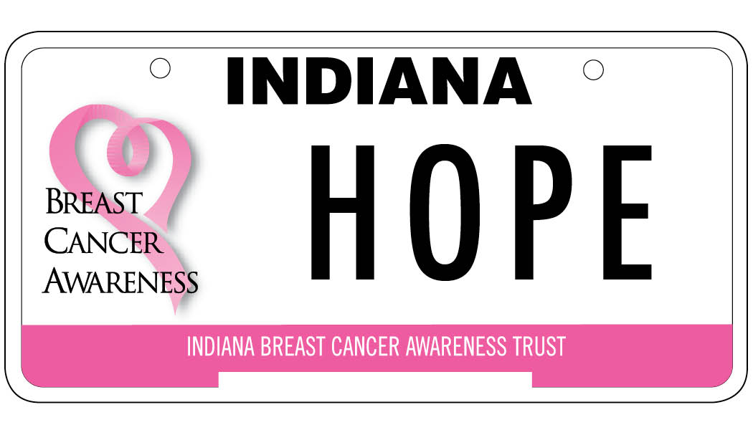

Nancy Jaynes Memorial Scholarship Award

Application Announcement

The Nancy Jaynes Memorial Scholarship Award is named in honor of the founder of the Indiana Breast Cancer Awareness Trust (IBCAT), Nancy Jaynes. Nancy lost her battle with breast cancer in March 2008. Nancy was a Plymouth (Indiana) High School Family and Consumer Sciences teacher. She envisioned the breast cancer license plate to be a traveling billboard and reminder about the importance of early detection and prevention of breast cancer. The mission of the Indiana Breast Cancer Awareness Trust is to increase awareness and improve access to breast cancer screening, diagnosis and support services throughout Indiana. To date, IBCAT has funded over $6 million in grants supporting our mission in addition to $90, 000 in scholarships.

IBCAT is currently accepting applications for the Nancy Jaynes Memorial Scholarship. The scholarship of up to $2,500 for college or post-secondary technical schooling is awarded to an Indiana High School Senior(s) whose parent is currently battling breast cancer or who has lost a parent to breast cancer. Application guidelines and instructions are included in this announcement.

APPLICATION DEADLINE IS FEBRUARY 5, 2021.
Incomplete applications will not be considered.
Emailed and Faxed applications will not be accepted.

Guidelines and Instructions
Contact information for submission and inquiries:

Indiana Breast Cancer Awareness Trust
P.O. Box 8212
Evansville, IN 47716

Phone: 866.724.2228 (toll free)
Email: info@breastcancerplate.org

Purpose: The purpose of the Indiana Breast Cancer Awareness Trust, Nancy Jaynes Memorial Scholarship Award is to provide financial assistance for a student(s) who has a parent in active breast cancer treatment or who has lost a parent to breast cancer to attend a post-secondary educational program (technical school or university/college) through scholarship funds.

Eligibility Requirements: In order to be eligible for consideration, scholarship applicants must:
- Have a parent in active breast cancer treatment or has lost a parent to breast cancer.
- Be a high school senior, reside within and attend high school (or be home-schooled) in Indiana. (If you do not reside in Indiana, your application will not be considered.)
- Plan to pursue a degree, either full-time or part-time, in any accredited post-secondary institution in Indiana.
- Have a cumulative high school GPA of 2.8 on a 4.0 scale.
- Be a U.S. citizen, or documented permanent resident of the U.S. Race, color, creed or sex will not be factors in choosing the Award winner(s).
- Recipients will be asked to provide proof of acceptance to a college or university before receiving payment of the Award.

Application Submission Instructions: In order to be eligible for consideration, scholarship applications must:
- Be typed (preferred) or printed in blue or black ink on only one side of the page. Essays must be typewritten.
- Be clearly legible and submitted in English. IBCAT is not responsible for mistakes made due to illegible applications.
- Be submitted in hard copy. Applications received by fax or email will NOT be accepted.
- Be submitted in the same order as received. Applications may be paper clipped in their entirety, but please do not separate/group parts of the application by paper clipping or stapling certain sections.
- Include current and accurate contact information. IBCAT will contact you at the phone number, email address, or physical address you provide.
- Provide all signatures where indicated on the application.

Application Timeline:
February 5, 2021: | Completed applications and all supporting materials due IBCAT.
April 15, 2021: | Scholarship award winner(s) will be notified by phone, mail or e-mail. The names and photographs of scholarship winners may be used by IBCAT for public relations purposes.

Application Checklist: Please submit application items in the order listed. Recommendation letters may be sent separately by the recommenders.
Fully Completed and Signed Application
Completed High School Counselor Information Form
Official High School Transcript
One Letter of Recommendation from High School Teacher (past or present)
One Letter of Recommendation from another source (ie. employer, pastor, coach, etc.)
Essay on Topic Provided

DO NOT INCLUDE PAGES 1 & 2 WITH APPLICATION. THESE PAGES ARE INFORMATIONAL ONLY.
Nancy Jaynes Memorial Scholarship Award
Application Form

Applicant's Full Name:
 | First | Middle | Last
Street Address:
City, Zip Code
Mailing Address (if different):
City, Zip Code
Birth Date:
Phone Number (Daytime):
Email:
How did you hear about this scholarship program?

Family Background

Custodial Father’s name:
Address:
Occupation:
Custodial Mother’s name:
Address:
Occupation:
Name of parent diagnosed w/breast cancer:
Year Diagnosed: |  | Current Treatment Plan:
Passed Away from Breast Cancer? Y / N

Number of other family members currently attending college, at least part-time, in your household: ____________

List all siblings in your household, their ages, and if they are dependent upon the family for support:

Name | Relationship | Age | Dependent upon family?
 |  |  | Yes | No

Educational Data

High School attending:
High School address:
Main phone number:
Counselor’s name:
Counselor’s phone number:
Counselor’s email address:

To what accredited post-secondary education institutions have you applied or plan to apply?

Name of Institution | City, State | Accepted? | Denied? | Pending?

Anticipated major or area of study?
What is your career goal?
Do you plan to live: On campus _______ |  | At home _______
Off campus_______ |  | Unknown _______

Have you been awarded other scholarships? Yes/No If yes, please list: __________________________________

__________________________________________________________________________________________
Extracurricular Activities – includes clubs, sports, student associations, etc.

Organization:  Example: Student Council | Description of activities:  President – conducted meetings; participated in coordinating homecoming parade, prom | Fresh. | Soph. | Jr.  X | Sr.  X

Community Service – includes non-paid service rendered in the community

Service/Volunteer work:  Example: Hospital Volunteer | Your specific role:  Helped in children’s ward | From-Thru:  10/18 – 6/19 | Hrs/week:  5

Talents/Awards/Honors

Talent/Award/Honor:  Example: Most Athletic | Description:  Voted as most athletic by senior class members | Fresh. | Soph. | Jr. | Sr.  X

Company:  Example: Ace Insurance, Inc. | Your specific role/job title:  Answered customer phone calls, filing | From-Thru:  05/19-03/20 | Hrs/week:  20
Employment/Internships/Summer Activities
High School Counselor Information Form

This form along with an official high school transcript must be submitted to the Indiana Breast Cancer Awareness Trust, P.O. Box 8212, Evansville, IN 47716. Postmark by February 5, 2021.

TO BE COMPLETED BY THE APPLICANT:
Name of Applicant: | Phone:

TO BE COMPLETED BY THE COUNSELOR:

Student’s rank: | Class size: | Cumulative GPA (use 4.0 scale): |  | Weighted or Unweighted GPA? (please circle one)
Total SAT score: |  | Total ACT Score:
If student has not taken SAT/ACT please list dates  he/she is scheduled to take them: |  | SAT:  ACT:

Has this student taken advantage of the most challenging opportunities your school has to offer (e.g., AP or honors courses, independent study, service organizations, academic clubs, etc.)?
Please explain any special circumstances or provide information and insights that would be helpful to the Award Committee.

Name: |  | Institution:
Position: |  | Phone:
Signature: |  | Fax:
Email: |  | Date:

ESSAY

Applicants are required to write an essay on: “Describe a unique situation or experience which occurred as a direct result of your parent being diagnosed with breast cancer.”

The Award Committee is concerned about the quality of your writing, but more importantly, about the quality of your thinking.

Your essay should be typed, double-spaced. It should be no more that 12 point font size and be no longer than 500 words. Include your name at the top of each page.

Scholarship Agreement

I certify that the information on this application and the supporting materials are complete, factually correct, and honestly presented. I further certify that, to the best of my knowledge, I meet all eligibility criteria noted above and understand the scholarship is contingent upon the following items:

- I will inform the Indiana Breast Cancer Awareness Trust, Inc. (IBCAT) by June 1, 2021 what post-secondary educational program I will be attending in the fall to allow time for the transfer of scholarship funds.

- I must attend an accredited post-secondary institution in Indiana.

- I agree to the releasing of high school transcripts and requested information to IBCAT. Furthermore, my name and photograph may be used by IBCAT for public relations purposes.

__________________________________
Applicant’s Signature

__________________________________
Applicant’s Name (Printed)

____________________________
Date

